CONTENTS

DESCRIPTION PAGENO

ABSTRACT
INTRODUCTION
ORGANIZATION PROFILE
MODULE DESCRIPTION
TECHNOLOGY
DATAFLOW DIAGRAMS
SOFTWARE REQUIREMENTS
HARDWARE REQUIREMENTS
OVERVIEW OF .NET TECHNOLOGY
OUTPUTS
CONCLUSION
BIBLIOGRAPHY

ABSTRACT
Advances in technology and the growth of Integrated Collage Management System to provide educators and trainers with unique opportunities to enhance learning and teaching in corporate, government, healthcare, and higher education. This application serves as a forum to facilitate the exchange of information on the current research, development, and practice of Integrated Collage Management System in the sectors.
It includes the research, development, and practice of Integrated Collage Management System related to the following multi-dimensional topics and sub-topics.
GreenWich comes in different configurations that dictate the depth of a needs assessment. The simple Integrated Collage Management System implementations, such as those following an application service provider (ASP) model, won't necessarily look any different from a resource requirement perspective than traditional classroom training. That's GreenWich.
GreenWich can be an enormous undertaking and, require significantly more preparation due to its increased scope, higher interdependence, and visibility. These factors--described below--are the reason a needs assessment for an Integrated Collage Management System initiative looks different from one for a traditional classroom program.
- Scope. Developing an Integrated Collage Management System initiative is a typically much larger endeavor than that of an instructor-led training (ILT) program. Consider the increased expenses, number of people involved, development time, technological requirements, and delivery options.
- Interdependence. It's possible, even common, for an ILT program to be conducted without the knowledge of anyone but the participants, their immediate managers, and the training provider. In contrast, even the smallest Integrated Collage Management System program requires a wider group of people. Ranging from (at a minimum) representatives from the IT and HR departments to (more commonly) an organization-wide task force, the scope of the project often dictates that there are more decision makers, more stakeholders, and more links between previously unrelated departments.
- Visibility. When a traditional training program goes bad, a participant's dissatisfaction is usually voiced by word of mouth. And the people who express dissatisfaction, in most cases, are the participants and, maybe later, the people directly affected by their work. Again, due to the scope of the undertaking (especially the high budget and number of resources required), the efficacy of an Integrated Collage Management System program will be delivered to a larger group of people and through a wider variety of channels than an ILT program. Typically, a CEO can tap into a training database and view participants' course comments, exam results, and the courses taken. It's easier to determine whether an Integrated Collage Management System program is unpopular or ineffective than to rely on word of mouth about a questionable ILT program.

INTRODUCTION
In order for a needs assessment to have a successful outcome, it must accomplish many things--improving performance being just one. It must also
- determine how to achieve the high-level goals of the organization (such as increasing sales and fostering innovation)
- determine what system obstacles (other than training) need to be removed
- point to an intervention that will balance the conflicting needs of different stakeholders (IT versus HR, participants versus managers, budget versus vendor costs, and so on)
- Pave the way for a new program.
Organizations implementing Integrated Collage Management System programs need to expand the usual needs assessment process by creating a high-level requirements document that includes
- objectives (macro organizational objectives and micro target learner population objectives)
- an Integrated Collage Management System readiness score
- a list of advantages and potential obstacles to Integrated Collage Management System adoption
- a list of possible Integrated Collage Management System configurations.

We apply technology with innovation and responsibility to achieve two broad objectives:

- Effectively address the business issues our customers face today
- Generate new opportunities that will help them stay ahead in the future

This approach rests on:
- A strategy where we Architect, Integrate and Manage technology services and solutions — we call it AIM for success.
- A robust offshore development methodology and reduced demand on customer resources
- A focus on the use of reusable frameworks to provide cost and time benefits

We combine the best people, processes and technology to achieve excellent results — consistently. We offer customers the advantages of:
Speed : We understand the importance of timing, of getting there before the competition. A rich portfolio of reusable, modular frameworks helps jump-start projects. Tried and tested methodology ensures that we follow a predictable, low-risk path to achieve results. Our track record is testimony to complex projects delivered within and even before schedule.

Expertise : Our teams combine cutting edge technology skills with rich domain expertise. What's equally important — we share a strong customer orientation that means we actually start by listening to the customer. We're focused on coming up with solutions that serve customer requirements today and anticipate future needs.
A Full Service Portfolio: We offer customers the advantage of being able to Architect, Integrate and Manage technology services. This means that they can rely on one, fully accountable source instead of trying to integrate disparate multi-vendor solutions.
Services:GSS is providing its services to Sain medicaments Pvt. Ltd, Grace drugs and pharmaceuticals pvt ltd alka drugs and pharmaceuticals pvt ltd to name just a few with out rich experience and expertise in Information Technology we are in the best position to provide software solutions to distinct business requirements.

MODULES
- Administration
- User Management
- Content Management
- Evaluation

MODULE DESCRIPTION

Administration:

- Uploading the content permanently
- Uploading the content temporally
- Removing the content permanently
- Removing the content temporally
- Working options
  - Caching Feature
  - Content length for each Category

User Management:

- User Information
- User Session Maintenance
- Updating User Information

Content Management:
These are the pages that are associated with the logic pages, and contain content specific to that page.

Organizing the topics according to the category
- Organizing the subtopics according to the subcategory

- Providing appropriate links to specified category

Evaluation

- Preparing the question paper randomly according to the category
- Spot result evaluation
- Specifying level of evaluation

TECHNOLOGY

Technology Used:
- .Net
- IIS
- Oracle

Operating System:

  - Windows

DATA FLOW DIAGRAMS

Data flow diagram is a structure analysis tool that is used for graphical representation of Data processes through any organization . the data flow approach emphasis on the logic underlying the system, by using combination of only 4 symbols. It follows a top down approach. A full description of a system actually consists of set of DFD s , which comprises of various levels. And initial over view model is exploded lower level diagrams that show additional feature of the system. Further each process can be broken down into a more detailed DFD. This occurs repeatedly until sufficient details is described.
DFD symbols
square

it defines a source (originator ) or destination of system data.

Arrow

It indicates data flow-data in motion. It is a pipeline through which information flows.

Circle or Bubble

It represents a process that transforms incoming data flow(s) into outgoing data flow(s).

Open Rectangle



it is a data store-data at rest, or a temporary repository of data. Here I am giving only the Data Flow Diagram.

They are explained by
- GANE and SARON method
- DEMACRO YORDAN method

GANE AND SARSON NOTATION

DATA FLOW

DATA STRUCTURE

EXTERNAL ENTITY
OR DATA LINK

PROCESS

DATA BASE

DEMACRO YORDAN NOTATION

DATA FLOW

DATA STRUCTURE

EXTERNAL ENTITY
OR DATA LINK

PROCESS

DATA BASE 

CONTEXT LEVEL DIAGRAM

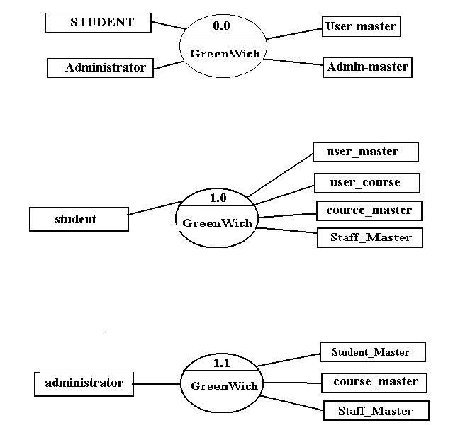

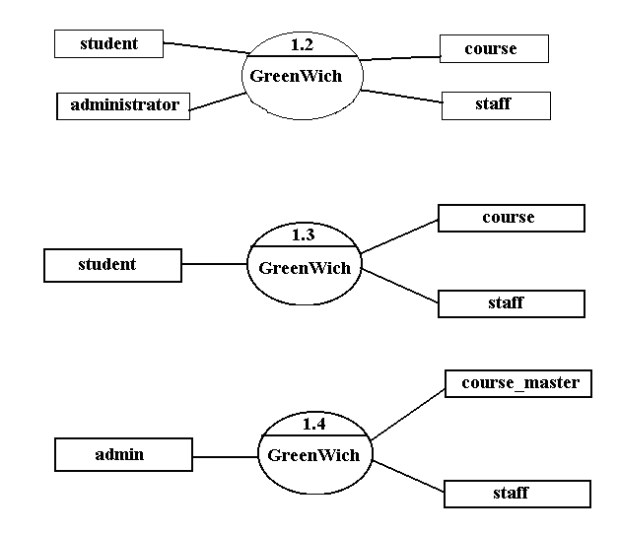

E – R DIAGRAMS.

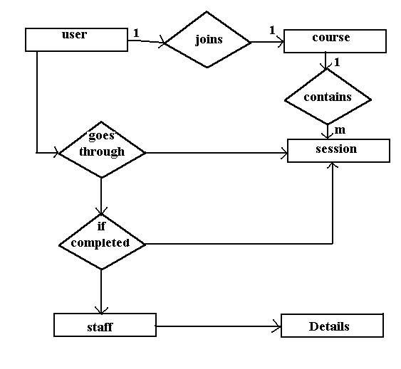

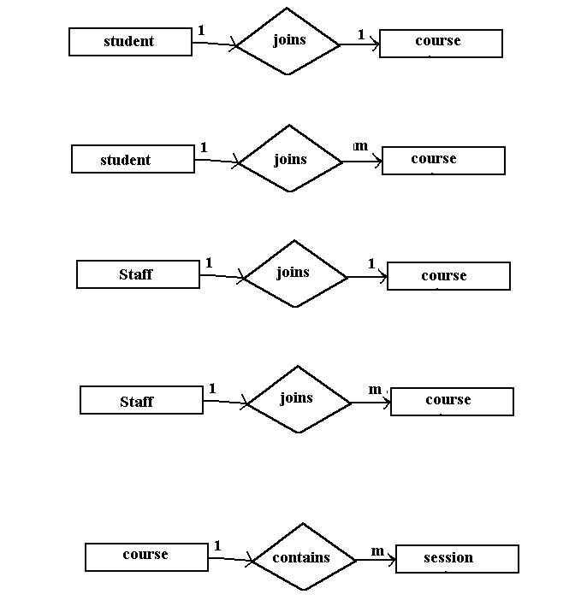

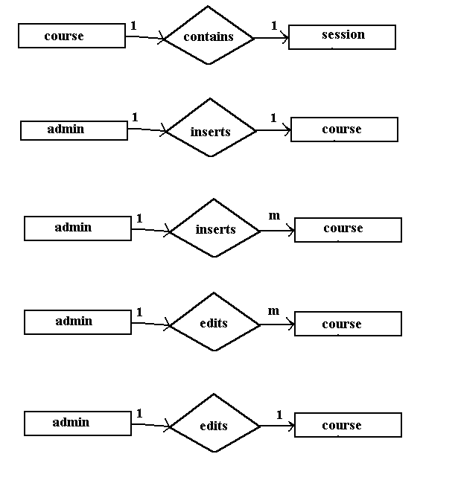

UML ANALYSIS

Examination
Content mgmt
Course
Reg
Staff
appointment
Qestions
New course
Staff Details
Administrator
Student
Registration
Courses

Sequence Diagram

Student
Courses
Staff
Admin

Register A New Course

Modify of Students Session

Modification of Courses

Cancellation of Courses / Staff

Register a Course ()

Accepted / Rejected the Registration of Course()

Request for Staff ( )

Result evaluations of the Student

Request for Extension of the Scheduled Time ()

Accepted / Rejected the Request of the Student()

`
Updating on Courses

Menu
Input Screen
Options
Report
Data Manipulator
Data Store
GUI Component
Greenwich
User_Main
Stafff
User_Sub
students
Search by course
Content dev
Profile Manipulation
Staff det
Course det
Student det
Questions
evaluation
Discussions
<<instantiates>>
<<uses>>

State diagram for registration process

Accept User Details
Specify user/Admin
User Input
User/Admin
Validate

DATA DICTIONARY.
Database Design:

T_Admin

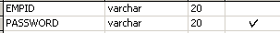

T_CourseReg

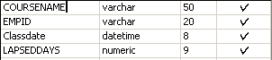

T_Courses

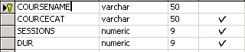

T_Emp_Personal

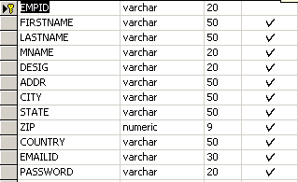

Staff_Master

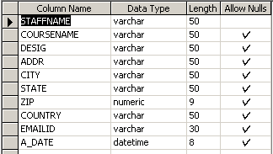

HARDWARE & SOFTWARE SPECIFICATIONS

- HARDWARE REQUIREMENTS:

PIII 500MHZ or above
128MB RAM
100MB Free Hard disk space
STD Color Monitor
Network interface card or Modem (For Remote Access)
LAN Network (For Remote Aources)

- SOFTWARE REQUIREMENTS:

WINDOWS NT 4 | 2000 | 9.X | ME
Visual Studio .Net 2002 Enterprise Edition
Visual Studio .Net Framework (Minimal for Deployment)

STUDY OF THE SYSTEM

Creating Database:

Microsoft® SQL Server™ server management comprises a wide variety of administration tasks, including:
- Registering servers and assigning passwords.
- Reconfiguring network connectivity.
- Configuring standby servers.
- Setting server configuration options.
- Managing SQL Server messages. Etc
In most cases, you do not need to reconfigure the server. The default settings for the server components, configured during SQL Server Setup, allow you to run SQL Server immediately after it is installed. However, server management is necessary in those situations where you want to add new servers, set up special server configurations, change the network connections, or set server configuration options to improve SQL Server performance.

Creating a Database
To create a database determine the name of the database, its owner (the user who creates the database), its size, and the files and filegroups used to store it.
Before creating a database, consider that:
- Permission to create a database defaults to members of the sysadmin and dbcreator fixed server roles, although permissions can be granted to other users.
- The user who creates the database becomes the owner of the database.
- A maximum of 32,767 databases can be created on a server.
- The name of the database must follow the rules for identifiers.
Three types of files are used to store a database:
- Primary files
These files contain the startup information for the database. The primary files are also used to store data. Every database has one primary file.
- Secondary files
These files hold all the data that does not fit in the primary data file. Databases do not need secondary data files if the primary file is large enough to hold all the data in the database. Some databases may be large enough to need multiple secondary data files, or they may use secondary files on separate disk drives to spread the data across multiple disks.
- Transaction log
These files hold the log information used to recover the database. There must be at least one transaction log file for each database, although there may be more than one. The minimum size for a log file is 512 kilobytes (KB).

When a database is created, all the files that comprise the database are filled with zeros to overwrite any existing data left on the disk by previously deleted files. Although this means that the files take longer to create, this action prevents the operating system from having to fill the files with zeros when data is written to the files for the first time during usual database operations. This improves the performance of day-to-day operations.

Create a database using the Create Database Wizard (Enterprise Manager)
To create a database using the Create Database Wizard
- Expand a server group, and then expand the server in which to create a database.
- On the Tools menu, click Wizards.
- Expand Database.
- Double-click Create Database Wizard.
- Complete the steps in the wizard.

Creating and Modifying a Table
After you have designed the database , the tables that will store the data in the database can be created. The data is usually stored in permanent tables. Tables are stored in the database files until they are deleted and are available to any user who has the appropriate permissions.

Temporary Tables
You can also create temporary tables. Temporary tables are similar to permanent tables, except temporary tables are stored in tempdb and are deleted automatically when no longer in use.
The two types of temporary tables, local and global, differ from each other in their names, their visibility, and their availability. Local temporary tables have a single number sign (#) as the first character of their names; they are visible only to the current connection for the user; and they are deleted when the user disconnects from instances of Microsoft® SQL Server™ 2000. Global temporary tables have two number signs (##) as the first characters of their names; they are visible to any user after they are created; and they are deleted when all users referencing the table disconnect from SQL Server.
For example, if you create a table named employees, the table can be used by any person who has the security permissions in the database to use it, until the table is deleted. If you create a local temporary table named #employees, you are the only person who can work with the table, and it is deleted when you disconnect. If you create a global temporary table named ##employees, any user in the database can work with this table. If no other user works with this table after you create it, the table is deleted when you disconnect. If another user works with the table after you create it, SQL Server deletes it when both of you disconnect.

Table Properties
You can define up to 1,024 columns per table. Table and column names must follow the rules for identifiers; they must be unique within a given table, but you can use the same column name in different tables in the same database. You must also define a data type for each column.
Although table names must be unique for each owner within a database, you can create multiple tables with the same name if you specify different owners for each. You can create two tables named employees and designate Jonah as the owner of one and Sally as the owner of the other. When you need to work with one of the employees tables, you can distinguish between the two tables by specifying the owner with the name of the table.
The above task can be achieved by using the component ASPEnterprisemanager which is part of the application. The component provides various methods in which a user can interact with the sql server resources located on a remote computer.
Before using the component the component has to attached to the application which can be done by double clicking on the solution name on the solution explorer. Browse the component and attach to the solution. Once the component is attached. The component can be used by importing it into the application as.
Imports system.aspenterprisemanager
By importing the component all the methods of the component can be used to interact with the SQL server.

SELECTED SOFTWARE

Microsoft.NET Framework
The .NET Framework is a new computing platform that simplifies application development in the highly distributed environment of the Internet. The .NET Framework is designed to fulfill the following objectives:
- To provide a consistent object-oriented programming environment whether object code is stored and executed locally, executed locally but Internet-distributed, or executed remotely.
- To provide a code-execution environment that minimizes software deployment and versioning conflicts.
- To provide a code-execution environment that guarantees safe execution of code, including code created by an unknown or semi-trusted third party.
- To provide a code-execution environment that eliminates the performance problems of scripted or interpreted environments.
- To make the developer experience consistent across widely varying types of applications, such as Windows-based applications and Web-based applications.
- To build all communication on industry standards to ensure that code based on the .NET Framework can integrate with any other code.
The .NET Framework has two main components: the common language runtime and the .NET Framework class library. The common language runtime is the foundation of the .NET Framework. You can think of the runtime as an agent that manages code at execution time, providing core services such as memory management, thread management, and remoting, while also enforcing strict type safety and other forms of code accuracy that ensure security and robustness. In fact, the concept of code management is a fundamental principle of the runtime. Code that targets the runtime is known as managed code, while code that does not target the runtime is known as unmanaged code. The class library, the other main component of the .NET Framework, is a comprehensive, object-oriented collection of reusable types that you can use to develop applications ranging from traditional command-line or graphical user interface (GUI) applications to applications based on the latest innovations provided by ASP.NET, such as Web Forms and XML Web services.
The .NET Framework can be hosted by unmanaged components that load the common language runtime into their processes and initiate the execution of managed code, thereby creating a software environment that can exploit both managed and unmanaged features. The .NET Framework not only provides several runtime hosts, but also supports the development of third-party runtime hosts.
For example, ASP.NET hosts the runtime to provide a scalable, server-side environment for managed code. ASP.NET works directly with the runtime to enable Web Forms applications and XML Web services, both of which are discussed later in this topic.
Internet Explorer is an example of an unmanaged application that hosts the runtime (in the form of a MIME type extension). Using Internet Explorer to host the runtime enables you to embed managed components or Windows Forms controls in HTML documents. Hosting the runtime in this way makes managed mobile code (similar to Microsoft® ActiveX® controls) possible, but with significant improvements that only managed code can offer, such as semi-trusted execution and secure isolated file storage.
The following illustration shows the relationship of the common language runtime and the class library to your applications and to the overall system. The illustration also shows how managed code operates within a larger architecture.

Features of the Common Language Runtime
The common language runtime manages memory, thread execution, code execution, code safety verification, compilation, and other system services. These features are intrinsic to the managed code that runs on the common language runtime.
With regards to security, managed components are awarded varying degrees of trust, depending on a number of factors that include their origin (such as the Internet, enterprise network, or local computer). This means that a managed component might or might not be able to perform file-access operations, registry-access operations, or other sensitive functions, even if it is being used in the same active application.
The runtime enforces code access security. For example, users can trust that an executable embedded in a Web page can play an animation on screen or sing a song, but cannot access their personal data, file system, or network. The security features of the runtime thus enable legitimate Internet-deployed software to be exceptionally feature rich.
The runtime also enforces code robustness by implementing a strict type- and code-verification infrastructure called the common type system (CTS). The CTS ensures that all managed code is self-describing. The various Microsoft and third-party language compilers

generate managed code that conforms to the CTS. This means that managed code can consume other managed types and instances, while strictly enforcing type fidelity and type safety.
In addition, the managed environment of the runtime eliminates many common software issues. For example, the runtime automatically handles object layout and manages references to objects, releasing them when they are no longer being used. This automatic memory management resolves the two most common application errors, memory leaks and invalid memory references.
The runtime also accelerates developer productivity. For example, programmers can write applications in their development language of choice, yet take full advantage of the runtime, the class library, and components written in other languages by other developers. Any compiler vendor who chooses to target the runtime can do so. Language compilers that target the .NET Framework make the features of the .NET Framework available to existing code written in that language, greatly easing the migration process for existing applications.
While the runtime is designed for the software of the future, it also supports software of today and yesterday. Interoperability between managed and unmanaged code enables developers to continue to use necessary COM components and DLLs.
The runtime is designed to enhance performance. Although the common language runtime provides many standard runtime services, managed code is never interpreted. A feature called just-in-time (JIT) compiling enables all managed code to run in the native machine language of the system on which it is executing. Meanwhile, the memory manager removes the possibilities of fragmented memory and increases memory locality-of-reference to further increase performance.
Finally, the runtime can be hosted by high-performance, server-side applications, such as Microsoft® SQL Server™ and Internet Information Services (IIS). This infrastructure enables you to use managed code to write your business logic, while still enjoying the superior performance of the industry's best enterprise servers that support runtime hosting.

.NET Framework Class Library
The .NET Framework class library is a collection of reusable types that tightly integrate with the common language runtime. The class library is object oriented, providing types from which your own managed code can derive functionality. This not only makes the .NET Framework types easy to use, but also reduces the time associated with learning new
features of the .NET Framework. In addition, third-party components can integrate seamlessly with classes in the .NET Framework.
For example, the .NET Framework collection classes implement a set of interfaces that you can use to develop your own collection classes. Your collection classes will blend seamlessly with the classes in the .NET Framework.
As you would expect from an object-oriented class library, the .NET Framework types enable you to accomplish a range of common programming tasks, including tasks such as string management, data collection, database connectivity, and file access. In addition to these common tasks, the class library includes types that support a variety of specialized development scenarios. For example, you can use the .NET Framework to develop the following types of applications and services:
- Console applications.
- Scripted or hosted applications.
- Windows GUI applications (Windows Forms).
- ASP.NET applications.
- XML Web services.
- Windows services.
For example, the Windows Forms classes are a comprehensive set of reusable types that vastly simplify Windows GUI development. If you write an ASP.NET Web Form application, you can use the Web Forms classes.

Client Application Development
Client applications are the closest to a traditional style of application in Windows-based programming. These are the types of applications that display windows or forms on the desktop, enabling a user to perform a task. Client applications include applications such as word processors and spreadsheets, as well as custom business applications such as data-entry tools, reporting tools, and so on. Client applications usually employ windows, menus, buttons, and other GUI elements, and they likely access local resources such as the file system and peripherals such as printers.
Another kind of client application is the traditional ActiveX control (now replaced by the managed Windows Forms control) deployed over the Internet as a Web page. This application is much like other client applications: it is executed natively, has access to local resources, and includes graphical elements.

In the past, developers created such applications using C/C++ in conjunction with the Microsoft Foundation Classes (MFC) or with a rapid application development (RAD) environment such as Microsoft® Visual Basic®. The .NET Framework incorporates aspects of these existing products into a single, consistent development environment that drastically simplifies the development of client applications.
The Windows Forms classes contained in the .NET Framework are designed to be used for GUI development. You can easily create command windows, buttons, menus, toolbars, and other screen elements with the flexibility necessary to accommodate shifting business needs.
For example, the .NET Framework provides simple properties to adjust visual attributes associated with forms. In some cases the underlying operating system does not support changing these attributes directly, and in these cases the .NET Framework automatically recreates the forms. This is one of many ways in which the .NET Framework integrates the developer interface, making coding simpler and more consistent.
Unlike ActiveX controls, Windows Forms controls have semi-trusted access to a user's computer. This means that binary or natively executing code can access some of the resources on the user's system (such as GUI elements and limited file access) without being able to access or compromise other resources. Because of code access security, many applications that once needed to be installed on a user's system can now be safely deployed through the Web. Your applications can implement the features of a local application while being deployed like a Web page.

Client Application Development
Client applications are the closest to a traditional style of application in Windows-based programming. These are the types of applications that display windows or forms on the desktop, enabling a user to perform a task. Client applications include applications such as word processors and spreadsheets, as well as custom business applications such as data-entry tools, reporting tools, and so on. Client applications usually employ windows, menus, buttons, and other GUI elements, and they likely access local resources such as the file system and peripherals such as printers.
Another kind of client application is the traditional ActiveX control (now replaced by the managed Windows Forms control) deployed over the Internet as a Web page. This application is much like other client applications: it is executed natively, has access to local resources, and includes graphical elements.
In the past, developers created such applications using C/C++ in conjunction with the Microsoft Foundation Classes (MFC) or with a rapid application development (RAD) environment such as Microsoft® Visual Basic®. The .NET Framework incorporates aspects of these existing products into a single, consistent development environment that drastically simplifies the development of client applications.
The Windows Forms classes contained in the .NET Framework are designed to be used for GUI development. You can easily create command windows, buttons, menus, toolbars, and other screen elements with the flexibility necessary to accommodate shifting business needs.
For example, the .NET Framework provides simple properties to adjust visual attributes associated with forms. In some cases the underlying operating system does not support changing these attributes directly, and in these cases the .NET Framework automatically recreates the forms. This is one of many ways in which the .NET Framework integrates the developer interface, making coding simpler and more consistent.
Unlike ActiveX controls, Windows Forms controls have semi-trusted access to a user's computer. This means that binary or natively executing code can access some of the resources on the user's system (such as GUI elements and limited file access) without being able to access or compromise other resources. Because of code access security, many applications that once needed to be installed on a user's system can now be safely deployed through the Web. Your applications can implement the features of a local application while being deployed like a Web page.

Server Application Development
Server-side applications in the managed world are implemented through runtime hosts. Unmanaged applications host the common language runtime, which allows your custom managed code to control the behavior of the server. This model provides you with all the features of the common language runtime and class library while gaining the performance and scalability of the host server.
The following illustration shows a basic network schema with managed code running in different server environments. Servers such as IIS and SQL Server can perform standard operations while your application logic executes through the managed code.
Server-side managed code
ASP.NET is the hosting environment that enables developers to use the .NET Framework to target Web-based applications. However, ASP.NET is more than just a runtime host; it is a complete architecture for developing Web sites and Internet-distributed objects using managed code. Both Web Forms and XML Web services use IIS and ASP.NET as the publishing mechanism for applications, and both have a collection of supporting classes in the .NET Framework.
XML Web services, an important evolution in Web-based technology, are distributed, server-side application components similar to common Web sites. However, unlike Web-based applications, XML Web services components have no UI and are not targeted for browsers such as Internet Explorer and Netscape Navigator. Instead, XML Web services consist of reusable software components designed to be consumed by other applications, such as traditional client applications, Web-based applications, or even other XML Web services. As a result, XML Web services technology is rapidly moving application development and deployment into the highly distributed environment of the Internet.
If you have used earlier versions of ASP technology, you will immediately notice the improvements that ASP.NET and Web Forms offers. For example, you can develop Web Forms pages in any language that supports the .NET Framework. In addition, your code no longer needs to share the same file with your HTTP text (although it can continue to do so if you prefer). Web Forms pages execute in native machine language because, like any other managed application, they take full advantage of the runtime. In contrast, unmanaged ASP pages are always scripted and interpreted. ASP.NET pages are faster, more functional, and easier to develop than unmanaged ASP pages because they interact with the runtime like any managed application.
The .NET Framework also provides a collection of classes and tools to aid in development and consumption of XML Web services applications. XML Web services are built on standards such as SOAP (a remote procedure-call protocol), XML (an extensible data format), and WSDL ( the Web Services Description Language). The .NET Framework is built on these standards to promote interoperability with non-Microsoft solutions.
For example, the Web Services Description Language tool included with the .NET Framework SDK can query an XML Web service published on the Web, parse its WSDL description, and produce C# or Visual Basic source code that your application can use to become a client of the XML Web service. The source code can create classes derived from classes in the class library that handle all the underlying communication using SOAP and XML parsing. Although you can use the class library to consume XML Web services directly, the Web Services Description Language tool and the other tools contained in the SDK facilitate your development efforts with the .NET Framework.
If you develop and publish your own XML Web service, the .NET Framework provides a set of classes that conform to all the underlying communication standards, such as SOAP, WSDL, and XML. Using those classes enables you to focus on the logic of your service, without concerning yourself with the communications infrastructure required by distributed software development.
Finally, like Web Forms pages in the managed environment, your XML Web service will run with the speed of native machine language using the scalable communication of IIS.

SCREENS

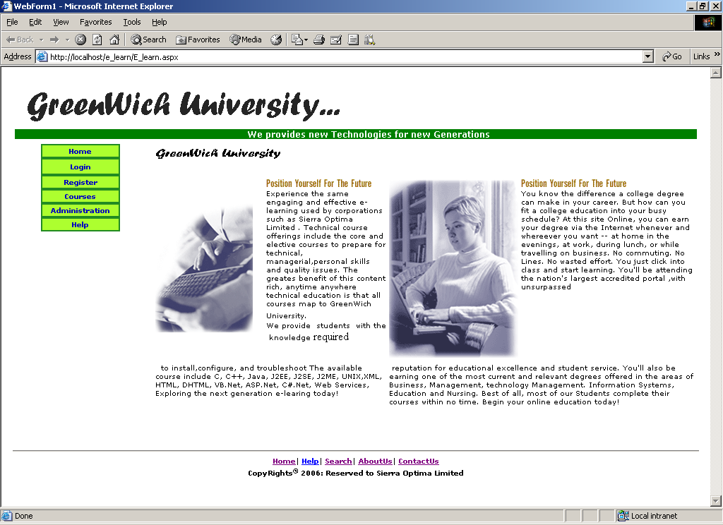

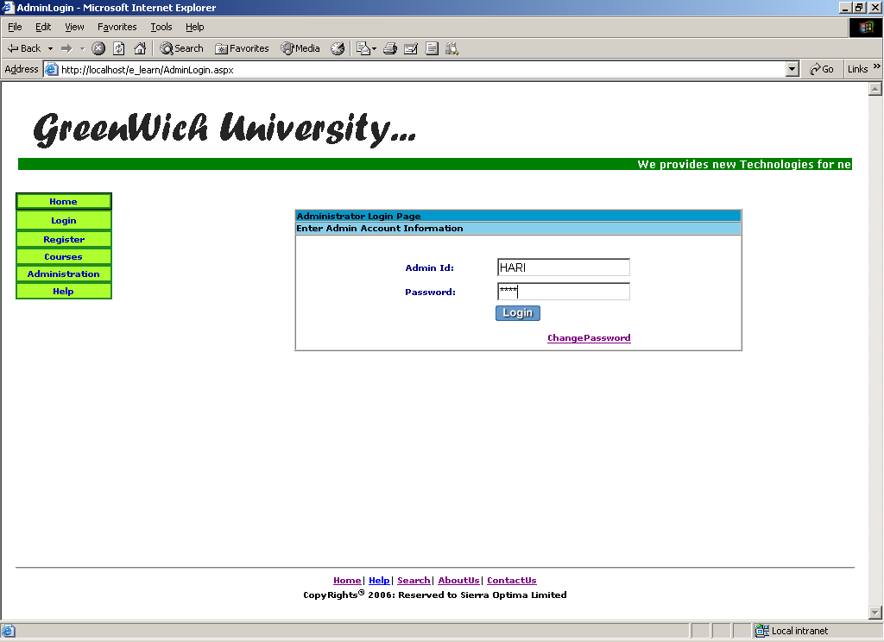

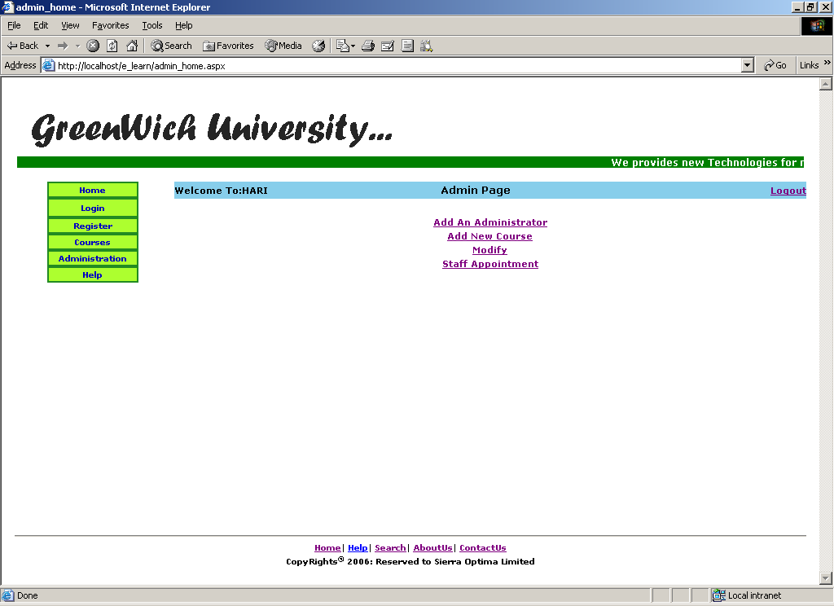
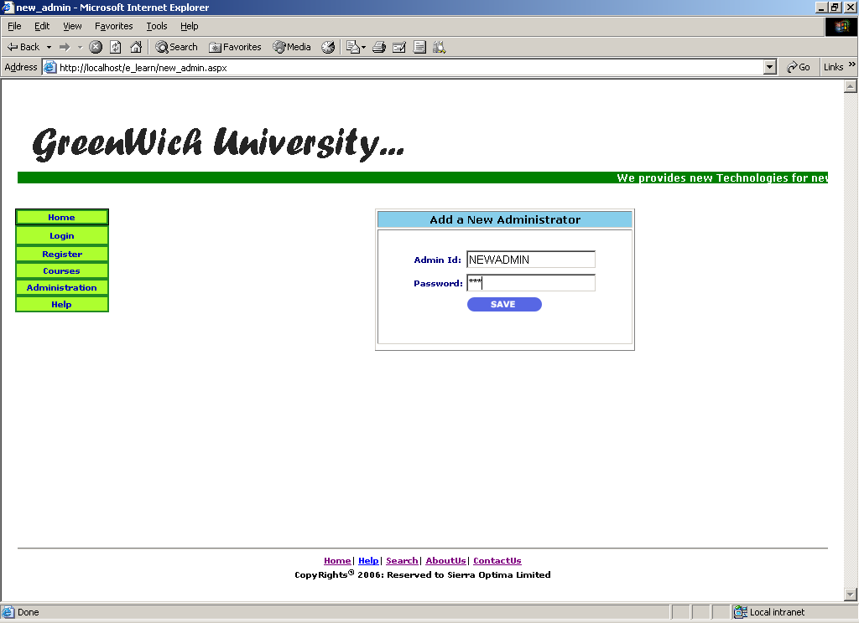

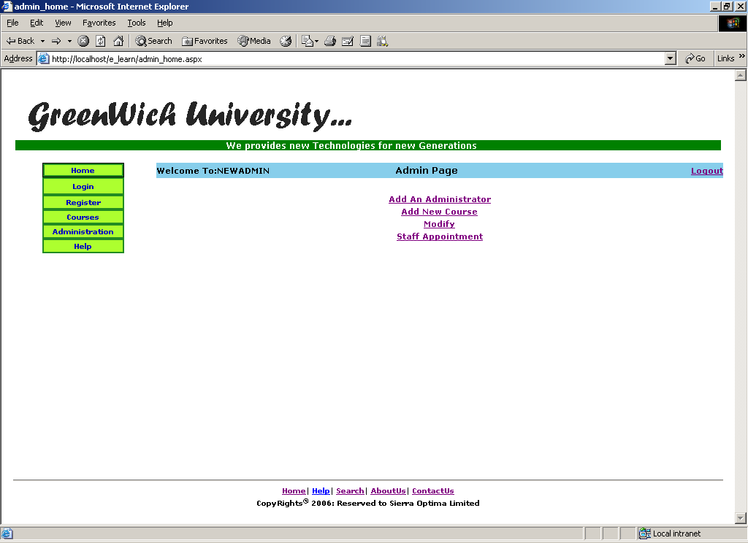
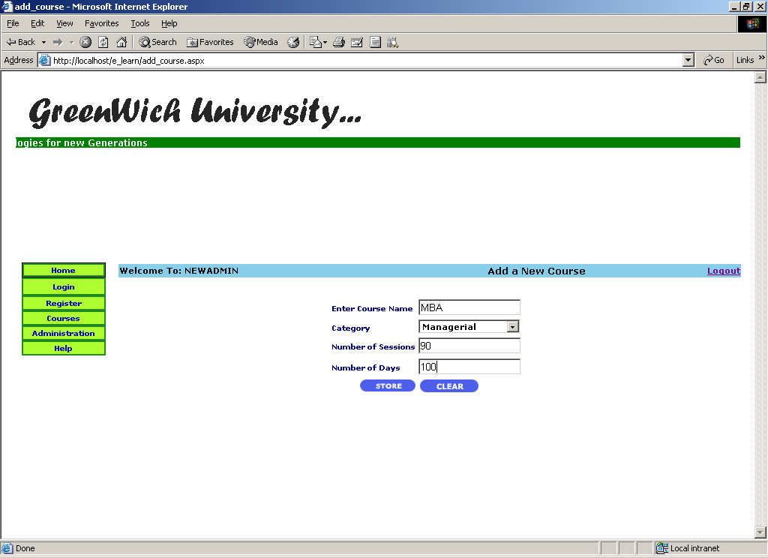

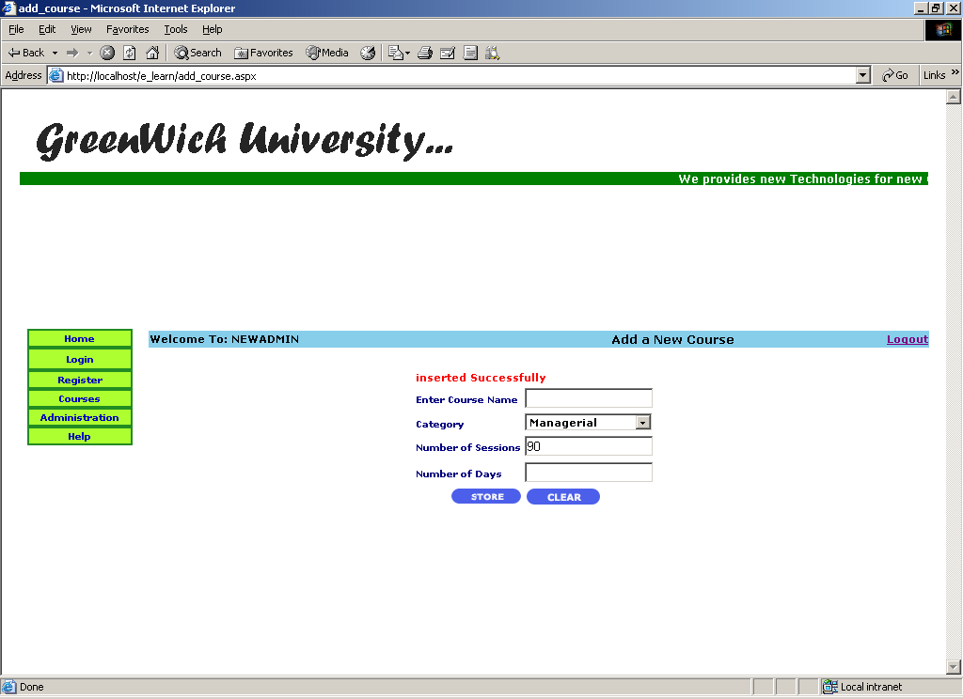
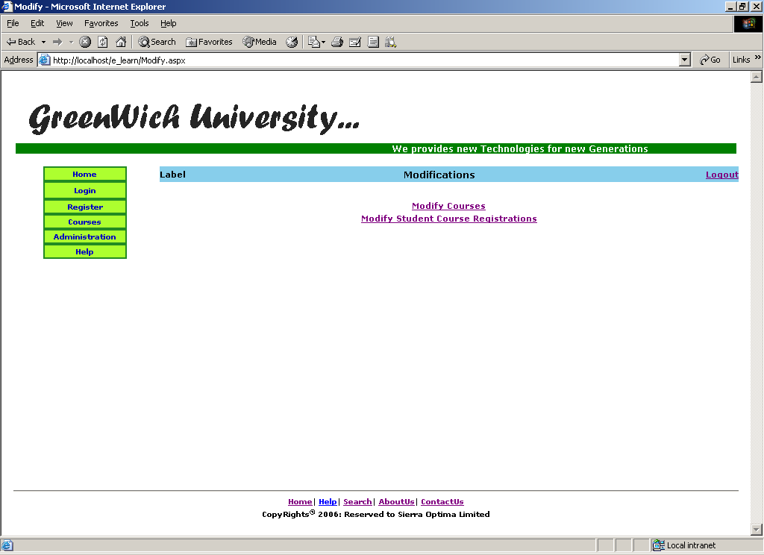

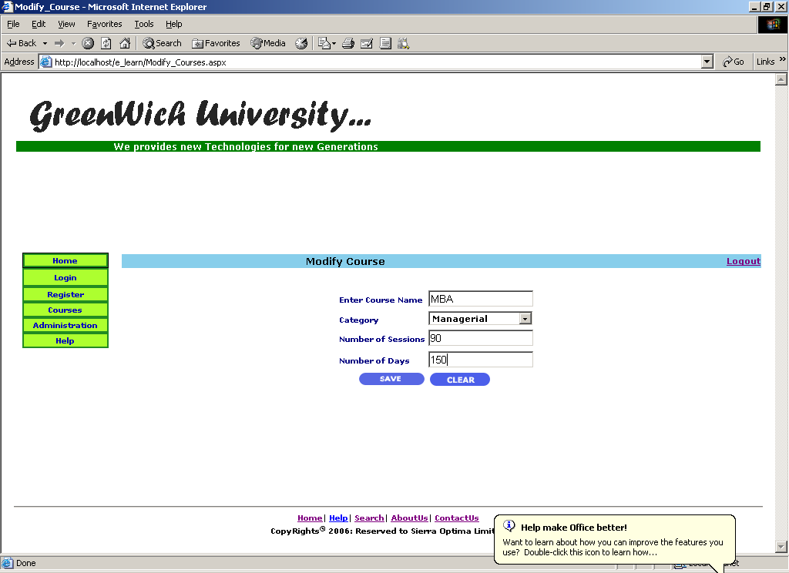

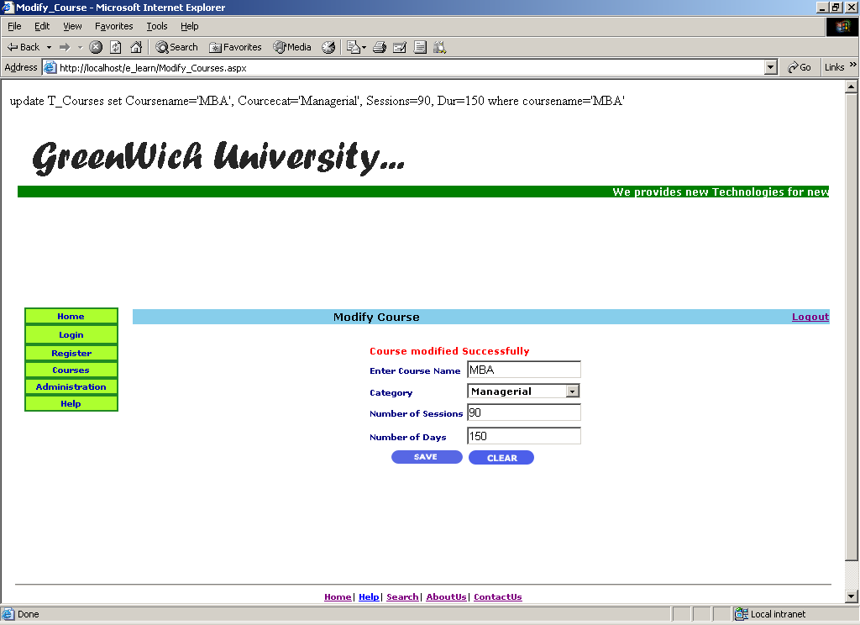

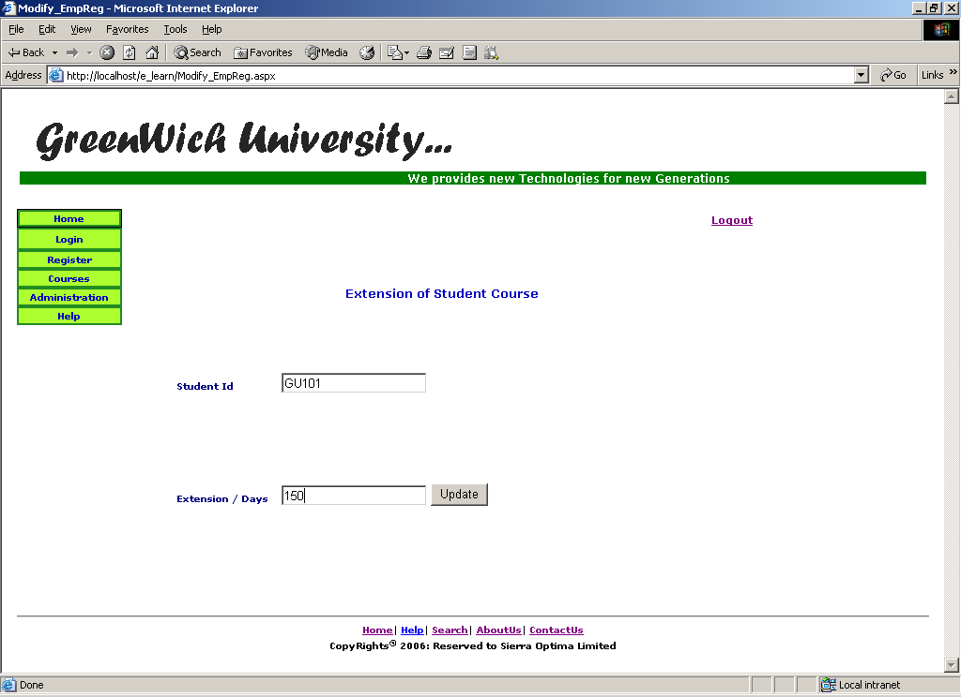

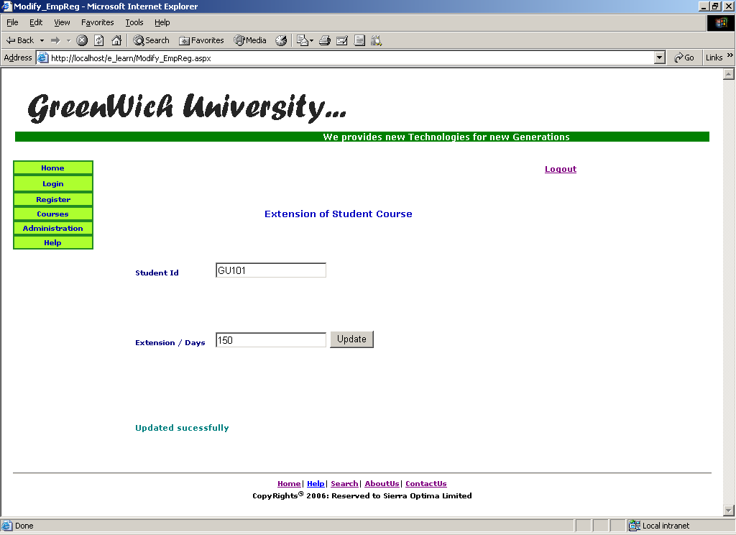

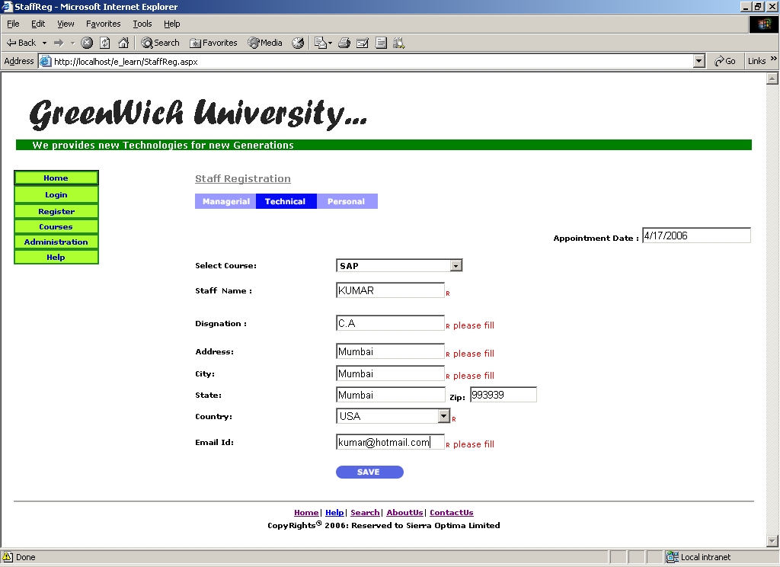

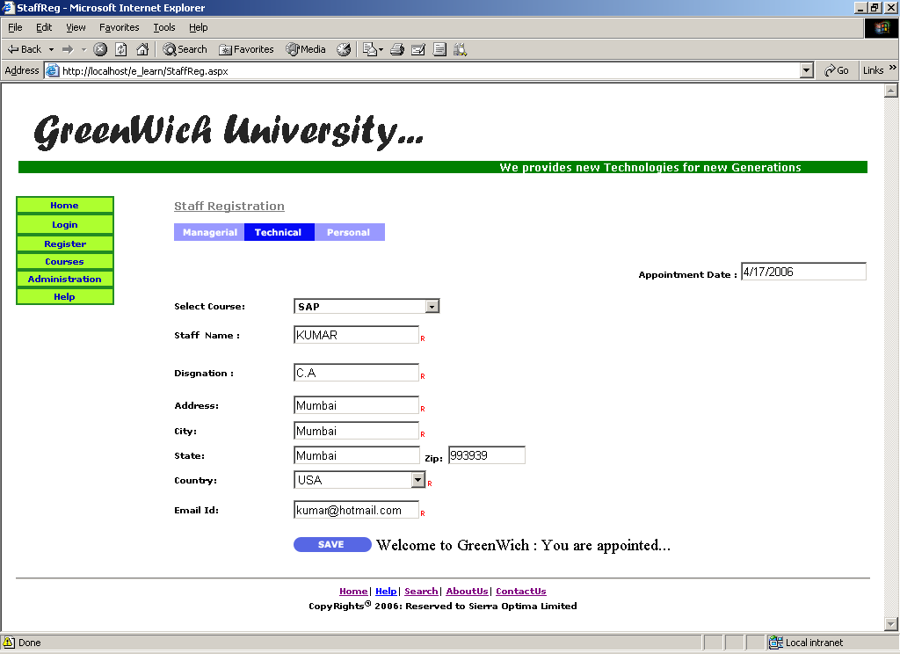

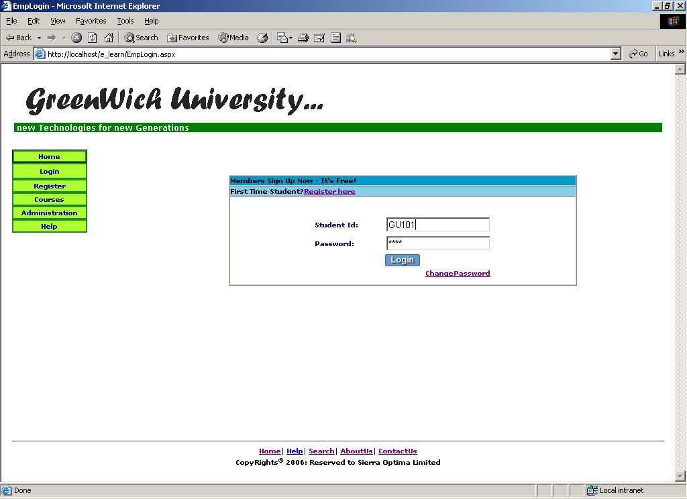

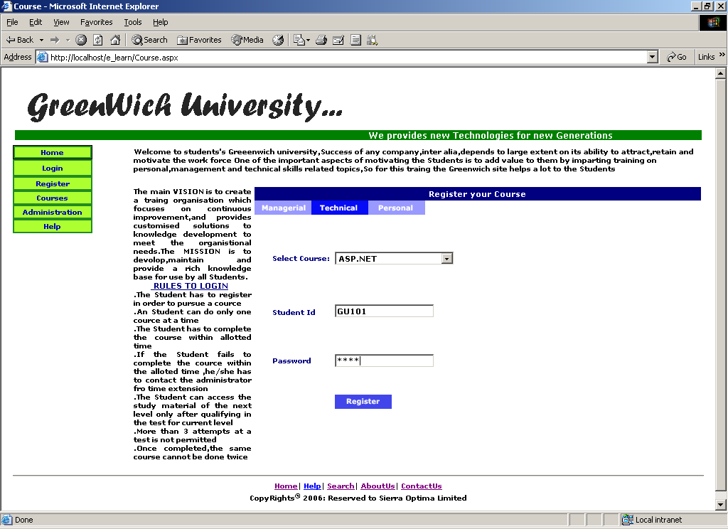
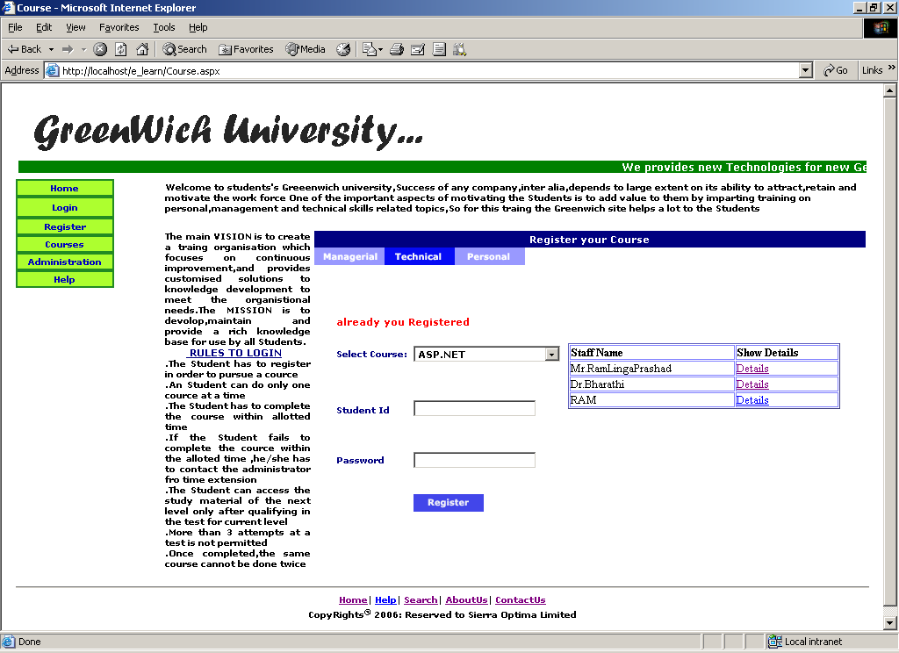

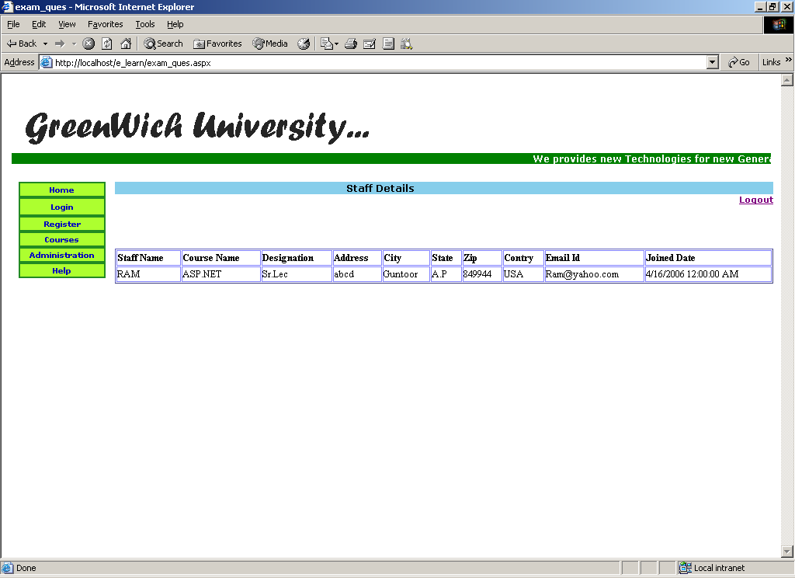

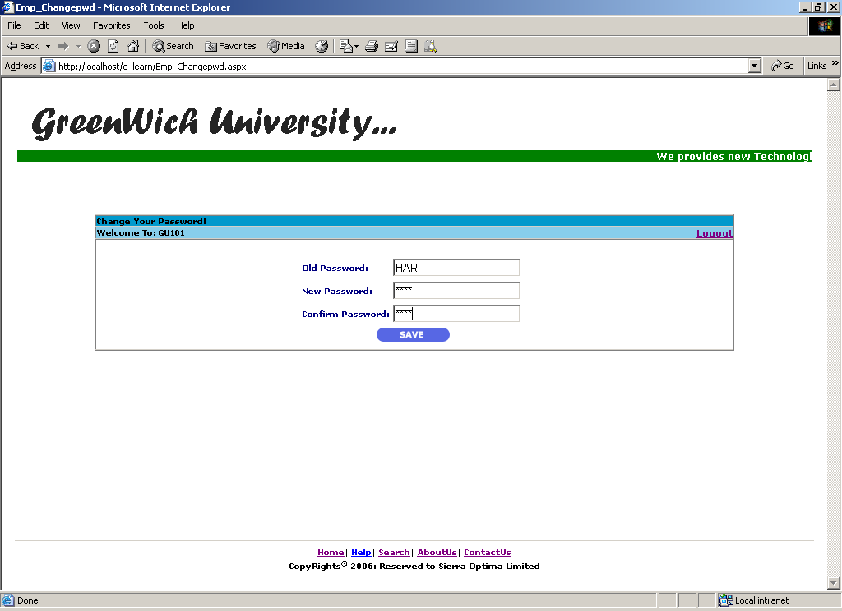

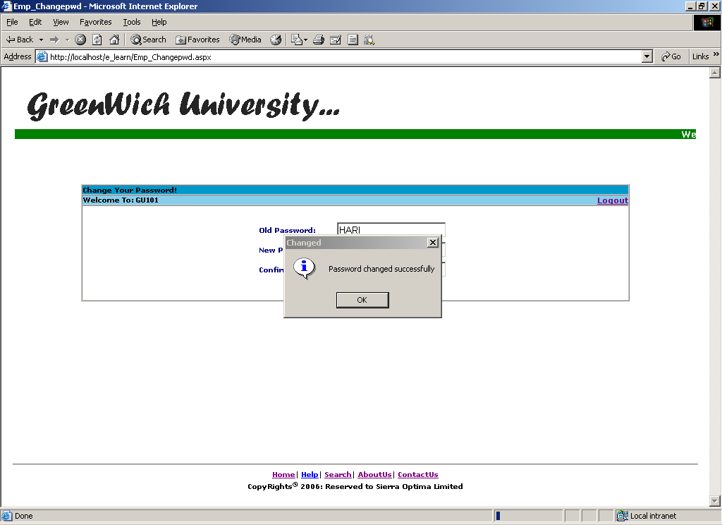

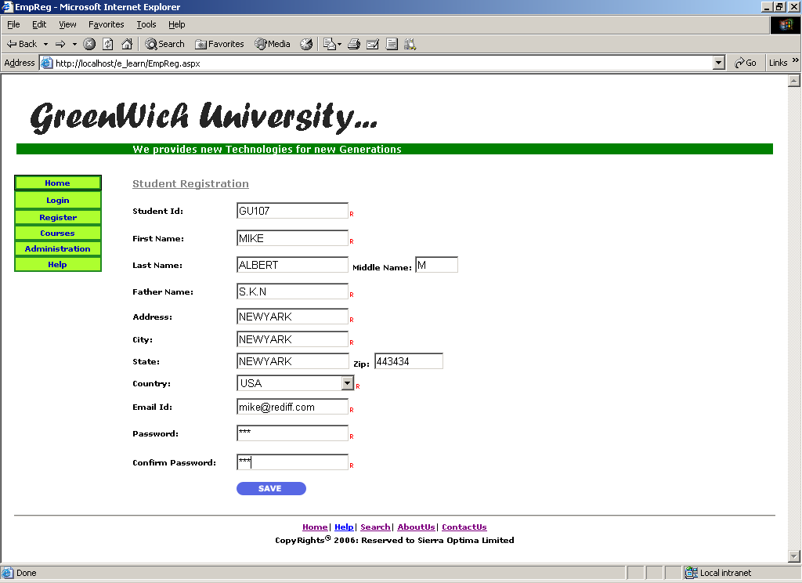

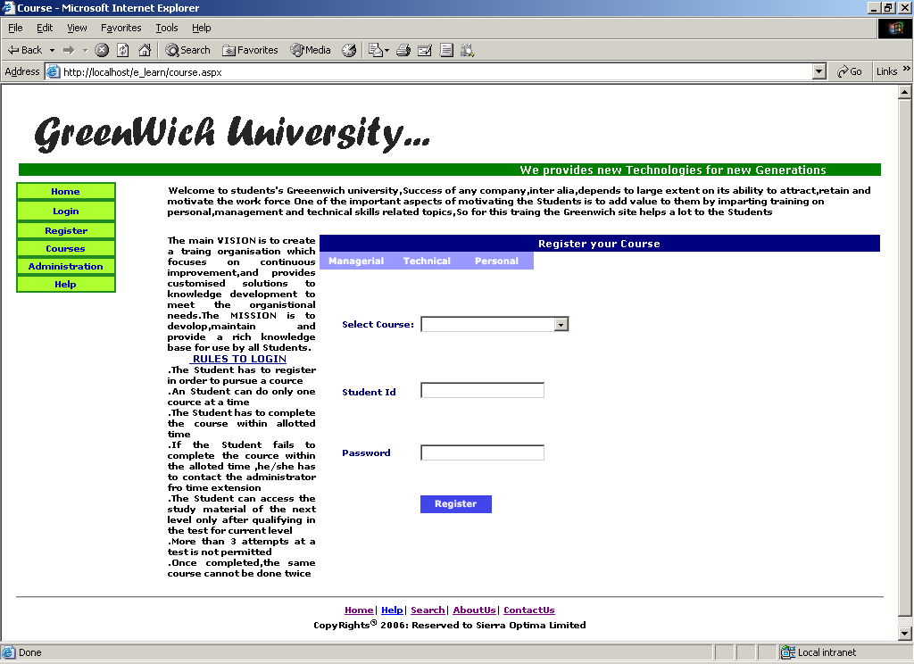

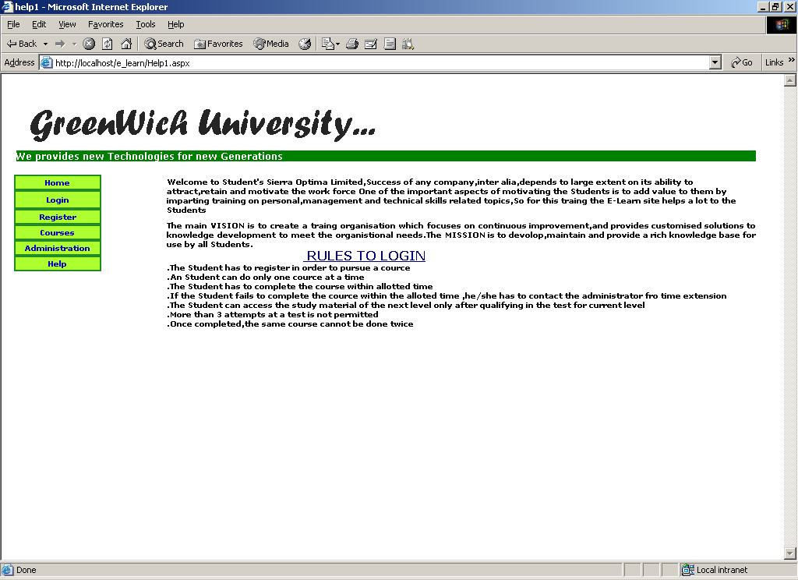

PROJECT TESTING

- COMPILATION TEST:
- It was a good idea to do our stress testing early on, because it gave us time to fix some of the unexpected deadlocks and stability problems that only occurred when components were exposed to very high transaction volumes.

- EXECUTION TEST:

- This program was successfully loaded and executed. Because of good programming there were no execution error.

- OUTPUT TEST:

- The successful output screens are placed in the output screens section.

CONCLUSION

- The project has been appreciated by all the users in the organization.
- It is easy to use, since it uses the GUI provided in the user dialog.
- User friendly screens are provided.
- The usage of software increases the efficiency, decreases the effort.
- It has been efficiently employed as a tool for SQL Enterprise Manager.
- It also provides the user with variable options in administering.
- It has been thoroughly tested and implemented.

BIBLIOGRAPHY

SOFTWARE ENGINEERING
By Mr.HariNath

Professional ASP.NET 1.1
By Wrox

MSDN 2002
By Microsoft

